August 22, 2023
COLLABORATION MEETING GROUP NOTES
Welcome
- Kevin Curiel, Cornerstone
- Alex Fernandez, CODAC
- Eli Joy, CODAC
- Hailey Owen, AZ Complete Health
- Leah Morales, PCHD
- Kevin Hall, Tucson Police Department
- Claudia Adams, AZ Complete Health
- Christina Saxton, CODAC
- Adriana Laigo, PCHD
- Mayra Jeffrey, PCHD
- Elizabeth Stamm, PCHD
- Sarah Graham, Oxford House
- Arisia Lee, PCHD
- Mark Person, PCHD
- Nicole Struck, Tucson Osteopathic Medical Foundation
- Leah Morales, PCHD
- Kimberly Wang, PCHD
- Angela Nasewytewa, Tucson Indian Center
- Cheyenne Watson
- Shawn Wooll, CODAC

Community Events
- International Overdose Awareness Day
- Spanish Community Forum on Fentanyl Awareness
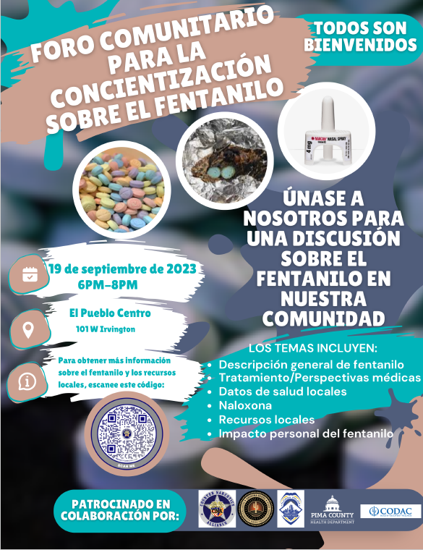

AZ Complete Health Update
- SABG screens individuals if they qualify for AHCCCS or lose funding.
- Let us know if there are any community needs or any gaps in services
- Reach out to Claudia at Claudia.Adams@azcomplete if you have any questions.
- New member - Hailey Owen, Program Specialist with the Soar grant.

Shawn Wool – Outreach Updates
- CODAC has started to engage in the schools more.
  - CODAC is providing peer support at Amphi Middle School.
  - Will be at Amphi middle school – tabling event for parents and students at 5 p.m.
  - Reducing stigma and providing support in the schools is one of our goals.
- Another event with TPD at Old Pueblo coming up.
- Mary St Paul – lots of members are signing up and making appointments and re-engaging with. Same with the Pima County jail.
- Alex – CODAC meets monthly with TPD.
  - There is a lot of focus on the 100 Acre area. Are others targeting other areas? Santa Cruz wash?
    - Shawn: There is a focus on the Santa Cruz wash and Rillito washes. TPD seeing a big uptick in sex trafficking because people are making more money. We are focusing on sex trafficking right to see what is going on.
    - 100 Acre area – The people camping there got a 72-hour notice to vacate. There are 10-20 motor vehicles out there. That has been TPDs focus. Problem is where do they go after they are kicked out.
    - We are entering our higher rain season and we want to get people out of the washes.
    - Section 8 is on hold.
    - HOPE & COPE and everyone is out in these areas offering services.
    - The plan is to ask Su Casa for help for the women and men being trafficked.

Data
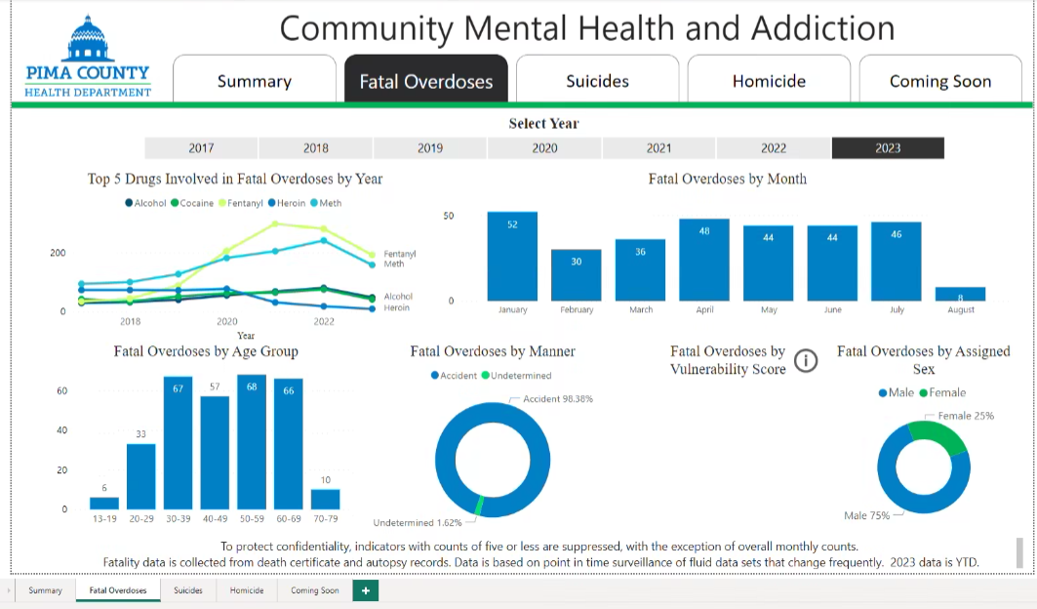
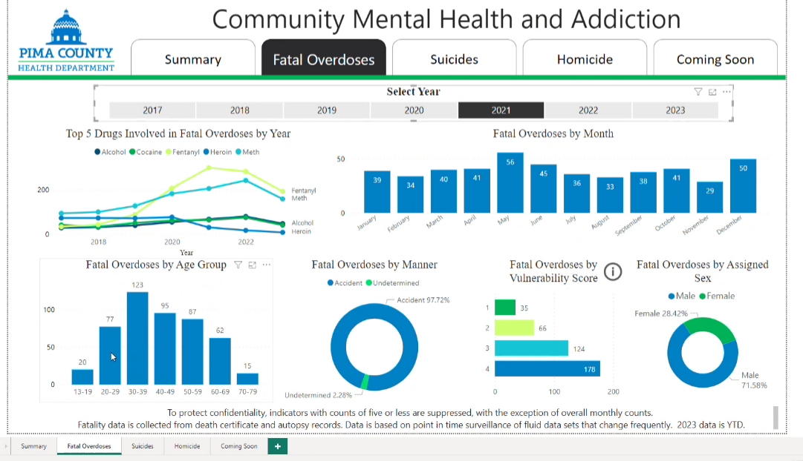
- PCHDs Community Mental Health and Addiction (CMHA) team sent out a Public Health Alert - Extreme Heat.
- PCHDs CMHA team also sent the following link in chat to the community – Heat and Prescription Drugs.
- We still have heat going on and overdoses happen over the summer frequently because of this effect.
- PCHDs CMHA team programmatic updates:
  - We are re-structuring and are creating a division because CMHA has grown. The new division will be called Community Addiction and Injury.
  - We will look at more than firearms, overdoses, and suicide. Will be looking at all natural deaths.
  - We applied for an Overdose to Action (OD2A) grant through the CDC.
    - We are fairly certain we received the award, but not sure the amount of the grant.
- Fatal Overdoses
  - The dashboard is refreshed frequently.
  - This is surveillance data. These numbers are a point in time count, not an official count. These are accurate numbers at this moment in time. The numbers will only go up.
  - Top 5 drugs
    - Individual drug counts.
    - There are not a lot of changes from last year – fentanyl & meth are still on the top of the chart. Fentanyl could increase a little from what we saw last year.
    - Since the 2021 top 5 ranking, not a lot has changed except some drugs have changed like heroin. Heroin keeps decreasing every year.
    - Cocaine and Meth in 2022 compared to 2023 are on almost an identical path.
    - A lot usually changes in summer months and spikes are usually seen, but this summer (2023) we have not seen major changes.
  - We can not share data from this dashboard, except in meetings, but a lot of this data can be accessed through Pima County’s Office of the Medical Examiner’s website: https://www.pima.gov/216/Data-Dashboards-Reports.
- Totals by Month
  - The biggest increase for 2023 was in April and then the numbers have stayed in mid-40’s. In summer months we see a little increase – heat is a factor. For the last 4 months we have been in 40’s compared to February and March. 2023’s end of the year total is expected to be similar to 2022’s total.
- Age Groups
  - The number for teenagers is a relatively low count at 6.
  - We usually see some fluctuation as the school year begins, but this number is still down from what we saw in previous years.
  - People in their 20’s.
    - We do not expect this number to increase much.
  - Middle age groups have increased.
    - All 4 age groups have come up together – all mostly identical.
    - In 2021, people in their 30’s had the highest numbers and numbers for people in their 40’s and 50’s trended down.
    - 2023 – now the people in their 40’s, 50’s, and 60’s are climbing to levels we have not seen before. We expect these numbers to rise before the year ends.
- Overdoses by manner
  - Accident versus undetermined.
    - 99% of cases have been ruled as an accident.
    - Intentional overdoses are ruled as a suicide.
- Overdoses by Sex
  - Usually sticks to 70/30 split male/female.
- Questions/Comments
  - Are all suspected overdose that involves a death investigated?
    - There are cases where Narcan is administered and not successful, but we don’t review all the records. Chances are that first responders will administer it if the person has faint vital signs. It is sometimes hard to gage if Narcan was successful. We don’t always know when it was administered. It’s hard to get the full picture.
  - We had consecutive years with increases, but it looks like it is leveling off or plateauing. Individual age groups have really benefitted from the community work – numbers for people in their teens and 20’s have come down a lot.

Healthy Pima News
- HealthyPima puts out a newsletter once a month. If you would like to receive or contribute to the newsletter, email Arisia.Lee@pima.gov.
- We have begun planning for the 2024 CHNA and will be doing a community survey for this CHNA.

CornerStone
- Substance abuse detox center.
- Acute stabilization.
- Work with the adult population.
- If need help reach out to Kevin Curiel
- Transportation falls on? Cornerstone does not provide transportation but will reach out to ACCHSS or community members to help.
- Only regards to substance abuse.
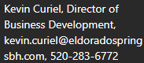

Updates/Announcements
- Sarah, Oxford House
  - An 11-bed house with a re-entry bed was opened on the west side.
  - A nascent re-entry program was started. A case worker can refer to the program. A person can stay in re-entry bed without being charged for a couple of weeks.
    - Alex: there are not always a lot of options. There are not a lot of services on the west side where the new house will be.

